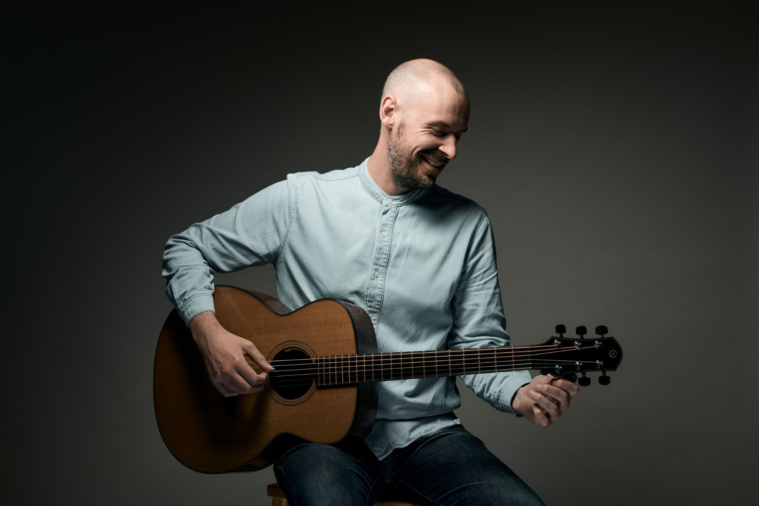
PRESS PHOTOS: DOWNLOAD HERE
LATEST ALBUM SILVER HORIZON DOWNLOAD HERE
LATEST SINGLE LONG TIME TRAVELLING DOWNLOAD HERE
Sam Carter • A Place To Call My Own • Live In Session
Sam Carter • Long Time Travelling • Official Video

SAM CARTER • TOURING AUTUMN 2025

BBC Folk Award-winning songwriter announces autumn tour

Midlands-born Sam Carter is a BBC Folk Award-winning singer-songwriter and guitarist renowned for his narrative-rich songwriting, which Uncut described as being “as penetrating as Richard Thompson’s best work”. For over 15 years, he has been stirring audiences from Camden to Canada, from major festivals to intimate clubs. Carter’s expressive fingerpicking led Jon Boden of Bellowhead to call him "the finest English-style fingerpicking guitarist of his generation," while Ivor Novello-winner Nitin Sawhney has praised his "killer voice."
With a discography that spans six solo albums and two releases with the folk-rock band False Lights, Carter’s music reflects a blend of traditional English folk, shape-note singing, and rock. Notable highlights in his career include a spellbinding performance on Later… with Jools Holland, where he played songs from his shape-note-inspired album The No Testament alongside renowned fiddler Sam Sweeney.
Carter’s latest release, the acclaimed Top 40 Folk Chart album Silver Horizon, has cemented his reputation as a skilful blender of ancient and modern. Produced by Andy Bell at the remote Red Kite Studios in Wales, the album's 11 indie-folk songs create a dreamlike soundscape, with guitarist Stuart McCallum (The Breath) adding lush, reverb-soaked textures. Carter says of this work, “I’m still dealing with themes of love, loss, and change... but sketching events in an impressionistic way gives the songs more room to breathe.”
Arriving hot on the heels of Silver Horizon, Carter’s latest single, Long Time Travelling (released April 2025), is a rousing arrangement of a 19th-century spiritual from The Sacred Harp, showcasing his intricate fingerstyle guitar work.
Sam Carter’s live performances are nothing short of captivating, filled with the raw honesty, humour, and skilled musicianship that underscore his standing as one of contemporary folk’s brightest talents.

SOLO AUTUMN TOUR • 2025

Sep 12 - West End Centre, Aldershot • westendcentre.co.uk
Sep 14 - Bristol Folk House • bristolfolkhouse.co.uk
Sept 17 - Willows Folk Club, Lancs • thewillowsfolkclub.co.uk
Sept 21 - Priston Festival, Somerset • priston.org.uk/festival
Oct 2 - Kitchen Garden Cafe, Birmingham • kitchengardencafe.co.uk
Oct 5 - The Live Room, Saltaire • theliveroom.info
Oct 10 - The Cube, Malvern • malverncube.com
Oct 18 - Indoor Folk Festival, Settle • settlevictoriahall.org.uk
Nov 14 - Saffron Hall, Essex • saffronhall.com

Regional PR
Jill Lerner, James Soars PR
Tel: 07702 230856
Email: jill.jameshsoars@gmail.com

www.samcartermusic.co.uk

